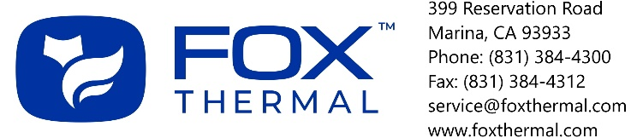 | RMA #:
 | Date:

RMA CUSTOMER INFORMATION FORM
Please follow these steps for your RMA to be processed correctly:
- Obtain a Return Material Authorization (RMA) Number from the Fox Customer Service Department.
- Fill out both pages of the RMA CUSTOMER INFORMATION FORM. Do not include these forms inside the box. Once completed and signed, fax or email these forms to Fox before shipping meter for repair/service.
- Clean and decontaminate all wetted parts before returning to Fox (see below).
- Unless specifically instructed to do otherwise, the entire flow meter must be returned, including all electronics.
  - For remote units or flow bodies, ALL serial numbers must match their corresponding meters.
  - Be sure to put the RMA number on the shipping labels and any additional paperwork.
  - Be sure to include a proper shipping address (we cannot deliver to post office boxes).
- Use extreme care to protect the sensor/probe when packaging for return to Fox. We highly recommend placing a piece of PVC pipe over insertion flowmeters sensor/probe and taping in place. Return inline flowmeters installed in its flow body. Surround the flowmeter with foam or bubble wrap and tape to ensure it stays in place. Popcorn packing material is not recommended.
  - We recommend returning the entire flowmeter. This allows us to perform complete diagnostic tests. Failure to return the entire flowmeter could result in out-of-specification performance.
  - We recommend returning electronic circuit boards in the flowmeter enclosure. This will help avoid shipping damage and help prevent circuit board failures due to electrostatic discharge.
- Ship the meter to the following address: Fox Thermal Instruments, Inc.
399 Reservation Road
Marina, CA 93933
Attn: Service Dept.
[RMA Number]

Fox will perform a Flow meter Evaluation for all flow meters returned for repair and/or calibration. A Flow meter Evaluation will include: firmware update (if required), electronics checks and diagnostics, sensor checks (including leakage current test), and verification of flow meter settings. The charge for this service is $100.00 USD. This charge applies even if the customer decides not to have the flow meter repaired or recalibrated. After the Flow meter Evaluation is complete, a quote for repair and/or recalibration can be made. If the flow meter is within the warranty period and the failure is determined to be a defect in material or workmanship, the evaluation fee is waived.

DECONTAMINATION INFORMATION:
Exposure to hazardous materials is regulated by Federal, State, County and City laws and regulations. These laws provide Fox employees with the “Right to Know” what hazardous or toxic materials or substances that they may come into contact with while handling products. Fox employees must have access to data regarding the hazardous or toxic materials or substances the equipment has been exposed to before its return. A Material Safety Data Sheet (MSDS) describing the hazardous or toxic materials that the product has been exposed to must accompany this form. This is true even after the product has been cleaned and decontaminated.
The person whose signature rests on this form must be a knowledgeable representative of the returning company that has received training and is responsible for the safe handling of the material to which the product has been exposed.
Any returns that lack the appropriate signature and/or required MSDS shall not be received for service and returned at the customer’s expense. RMA numbers will only be provided after this information has been received and reviewed.

DECONTAMINATION STATEMENT:
I certify that the returned item(s) has(have) been thoroughly and completely cleaned. If the returned item(s) has(have) been exposed to hazardous or toxic materials or substances, I confirm that MSDSs have been supplied for each material or substance. I understand that the acceptability of the cleanliness of the returned product(s) is at the sole discretion of Fox and may be returned at the customer’s expense if it is found to be unacceptable by Fox.

Product Serial #(s):
Hazardous materials or substances that have or may have been exposed to the product:
Check the appropriate box below:
 | I have attached the required MSDS |  |  |  |  |  |  |  | No MSDS is necessary
Authorized Signature: |  |  |  |  |  |  |  | Print Name:
Company Name: |  |  |  |  |  |  |  | Title:
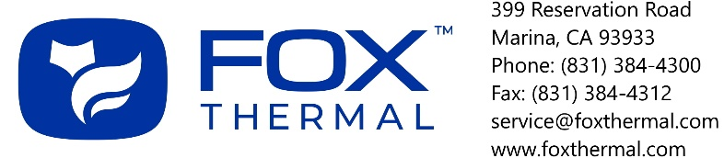 |  |  |  |  |  | RMA #:
 |  |  |  |  |  | Date:

RMA CUSTOMER INFORMATION FORM

1. | Customer Information
 | Returning Company: |  |  |  |  |  |  | Company Contact Name:
 | Phone: |  |  |  |  |  |  | Email:
2. | Addresses
 | Return to (customer): |  |  |  |  |  |  | Bill to (non-warranty):
3. | Product Information
 | Model #: |  |  |  |  |  |  | Serial #(s):
 | Steps taken before return (troubleshooting, phone technical support, etc):
 | Choose a reason for return of product:
 |  | Electronics Malfunction |  |  |  | Sensor Element Damage |  |  |  |  |  |  |  | Credit
 |  | Recalibrate (New Specs) |  |  |  | Recalibrate (Current Specs) |  |  |  |  |  |  |  | Other:
 | Detailed Description of Product Problem:
 | Additional services required (fee may apply):
 |  | “As Found” data and certificate ($210)* |  |  |  |  |  |  |  | “As Left” data and certificate ($110)
 |  | None |  |  |  |  |  |  |  | Other (specify):
 | *As Found Data: $210 with the recalibration of meter. As Found Data ONLY (no recalibration), please contact Fox for an estimate.
4. | Payment Information (non-warranty):
 |  | Purchase Order |  |  |  | Credit Card
 | Priced quotations are provided for all non-warranty repairs after a product evaluation has been completed. A minimum charge of $100 is applied to all non-warranty repairs.

Fox Office Use Only  Date Received: __________________________________  Warranty Non-warranty NWNC  Sales Order History: ______________________________  Customer Terms: _________________________________ | Factory Return Shipping Address: | Fox Thermal Instruments  399 Reservation Rd.  Marina, CA 93933  Attn: Service Dept.  [RMA #]

